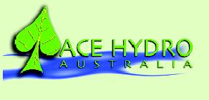

9thMay 2017

Dear Supplier

It is with sincere regret that I inform you that after 18yrs of business Ace Hydro Australia Pty Ltd will be closing its door permanently, whilst it has been a very difficult decision to make it is one we have had to come to.

I have really enjoyed every year at Ace Hydro from beginning to end, you have all been very good to me and I have made some great lasting friendships.

Of course this means we will no longer be purchasing from you and encourage you to look for another distributer to continue marketing your products.

Over the next 30-60 days, we ask for your patience and understanding as we go through the lengthy and very tedious process of finalising business matters.

We apologise in advance for any inconvenience caused but please know our priority will be to sell off all of our stock and call in all our debts which will then enable us to pay off any outstanding balances we have with you.

We would like to thank you for your past business; it was truly a pleasure working with you and your team. The staff here at Ace Hydro wish you all the very best and thank you for providing a fantastic service over the years to our company.

Please do not hesitate to contact us if you have any questions or concerns, we will do our best to address any issues you may have.

Thank you

Mr Stuart Grimmond

Director

Ace Hydro Australia